Dbt Test plan
You run dbt tests the same way you run models — with a single command. The short version:
Run all tests: dbt test
Run tests for one model: dbt test --select fct_orders
Run only schema tests: dbt test --data
Run only generic tests: dbt test –schema

How dbt executes tests
dbt looks inside your schema.yml files for built-in tests like:
- unique
- not_null
- accepted_values
Then it automatically generates SQL queries to validate data.
Example: A unique test becomes a query that checks for duplicate values. A not_null test becomes a query that checks for missing values.
If any rows fail, dbt marks the test as FAIL and shows you the failing rows.
Running all tests
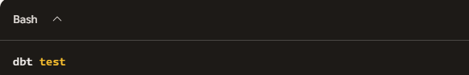

This runs:
- Schema tests
- Generic tests
- Custom tests
- Tests on sources
- Tests on snapshots
Everything.
Running tests for a specific model
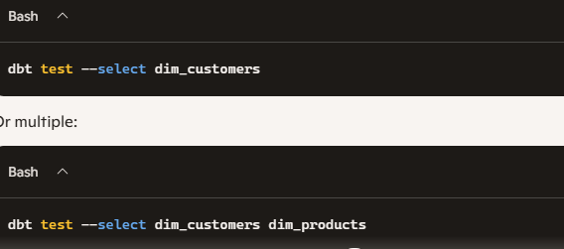

Running only certain types of tests
Only schema tests (unique, not_null, accepted_values)
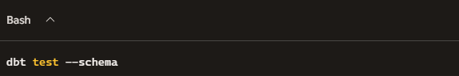

Only data tests (custom SQL tests)
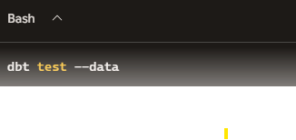
Running tests for a specific column
